Before starting, it is essential to define the main terms to avoid ambiguity or confusion. To study risk management, we need to ensure a proper understanding of the following terms:

Threat: an intentional or accidental event that can compromise the security of an information system. Examples include hacking, phishing attacks, human error, and natural disasters.
Vulnerability: a software, hardware, or network weakness that cybercriminals can exploit to gain unauthorised access or compromise a system.
Asset: a valuable resource or component (tangible or intangible) that an organisation relies upon to achieve its objectives.
Risk: the probability of a threat source exploiting an existing vulnerability and resulting in adverse business effects.
Risk Management (RM): the process of identifying, assessing, and mitigating risk to maintain acceptable levels.
Threat

A threat is a potential harm or danger to an individual, organisation, or system. Threats can be classified into three main categories: human-made, technical, or natural.

Human-made threats: These threats are caused by human activities or interventions. Examples include:

Terrorism
Wars and conflicts
Riots and civil unrest
Cyberattacks
Industrial accidents
Arson
As can be seen, human-made threats are not limited to cyberattacks; although they do not require technical expertise, arson is a grave threat. Realising any of these threats can have the power to disrupt the whole business; both a cyberattack and arson can prevent a company from functioning for a while.

Technical threats: These threats result from technological failures, malfunctions, or vulnerabilities. Examples include:

Power outages
Software and hardware failures
Data breaches
Network and system vulnerabilities
Equipment malfunctions
A power outage can halt an entire company without a backup power source. A failed power supply means the whole server is down unless another backup power supply is on standby. Any of these technical threats can prevent business processes from moving forward; therefore, considering each of these threats is a must in any risk analysis.

Natural threats: These are threats caused by natural events or phenomena. Examples include:

Earthquakes
Floods
Natural threats depend on the location of the company or data centre. Studying the natural hazards to which a particular area is exposed is necessary to ensure proper risk analysis.

Vulnerability
A vulnerability is a weakness in the system or software that can be exploited by a threat to cause harm. To elaborate, it is a weakness that can be exploited by malicious individuals, groups, or external factors to gain unauthorised access, cause damage, or compromise the integrity, availability, or confidentiality of a system, data, or network. Vulnerabilities can arise from software bugs, misconfigurations, or outdated security.

Asset
An asset is an economic resource owned or controlled by an individual, company, or government. It typically has the potential to provide some future benefit. Assets include cash and cash equivalents, accounts receivable, investments, stock, equipment, real estate, and intellectual property.

In the context of information systems, an asset in information systems refers to any valuable resource or component (tangible or intangible) that an organisation relies upon to achieve its objectives. These assets are critical for successfully operating and managing the organisation’s information processes.

Some examples of assets in an information system include:

Hardware: Servers, workstations, routers, switches, firewalls, and other physical devices used to store, process, and transmit information.
Software: Operating systems, applications, databases, and other programs that enable the organisation to perform its functions efficiently and effectively.
Data: Organisational data, which includes sensitive information such as customer records, financial data, intellectual property, and personal data of employees.
Documentation: Manuals, policy documents.
Risk
Risk is the probability of a threat source exploiting an existing vulnerability (in an asset) and resulting in adverse business effects.
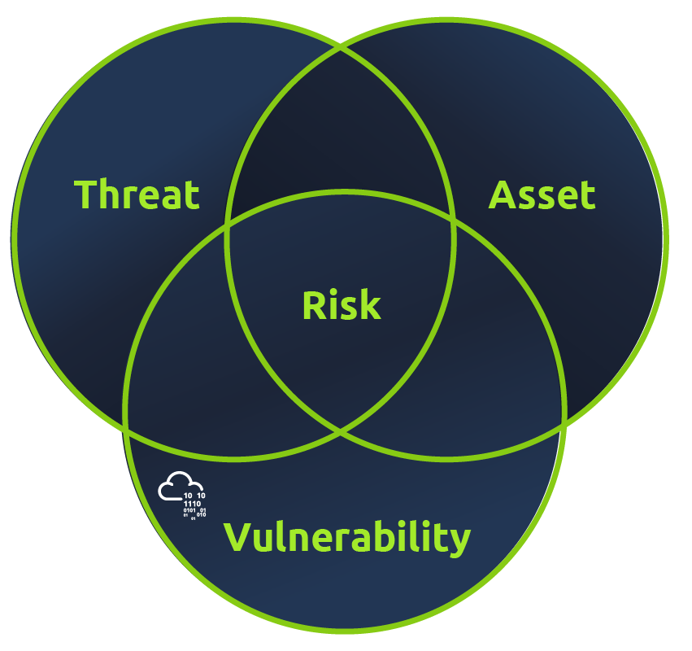
Risk is the potential of encountering unforeseen events or circumstances that may lead to a loss, damage, or negative outcome. It is the possibility of an undesirable consequence from an uncertain situation, and it can be present in various aspects of life, such as finance, health, and personal relationships. In a business context, it is the probability of a threat source exploiting an existing vulnerability and resulting in adverse business effects. Since the existence of assets is taken for granted, some references omit assets from the visual representation.
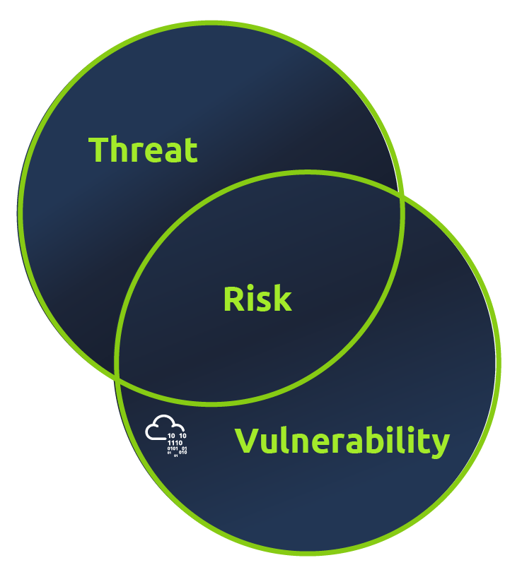
In information systems, risk refers to the potential threats, vulnerabilities, and negative consequences arising from the interaction between IT infrastructure, software applications, data, and users. It deals with the uncertainties organisations face in ensuring their digital assets’ confidentiality, integrity, and availability.
Risk Management

